Step 1.1. Install the 64bit Driver provided with the Printer – it has more options.

1.2. Set Font to **San Serif** (Hold Three Seconds on **Pause** Button > Press the **Font** Button till the Draft option is reached (Left light Off, Right light Flashing On/Off.) > Press on **Pause** to complete the Font setup.

Step 2. Add Paper Size as usual through Print Server Properties (*Screenshot on Page 2, since we already know how to do it*)

Step 3. Go to EPSON Printer Properties – No need for Generic Text Only

<<Printing Defaults>>

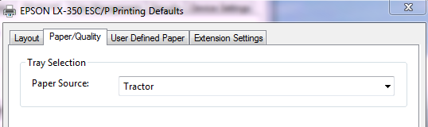

<<Advanced>>

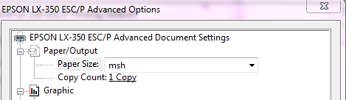

<<Device Settings>>

